ETL Pipeline Documentation
Olist BI Retail Project
Data Extraction, Transformation & Loading using Talend and PostgreSQL



- ETL Job Architecture

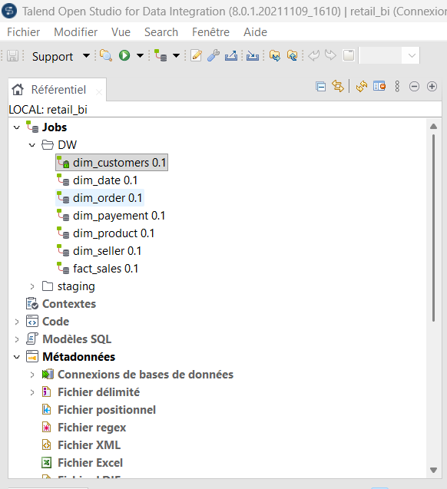

2.Customer dimention job ETL

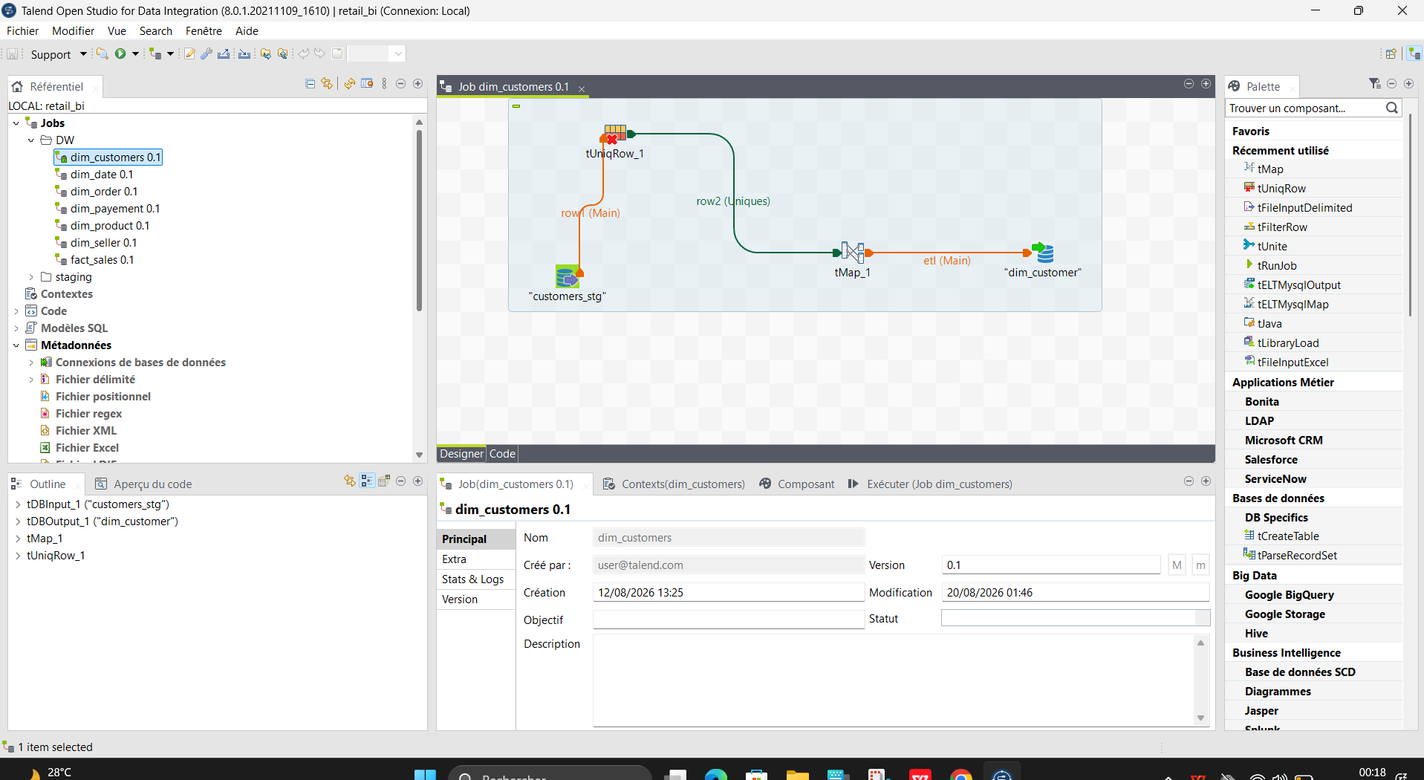

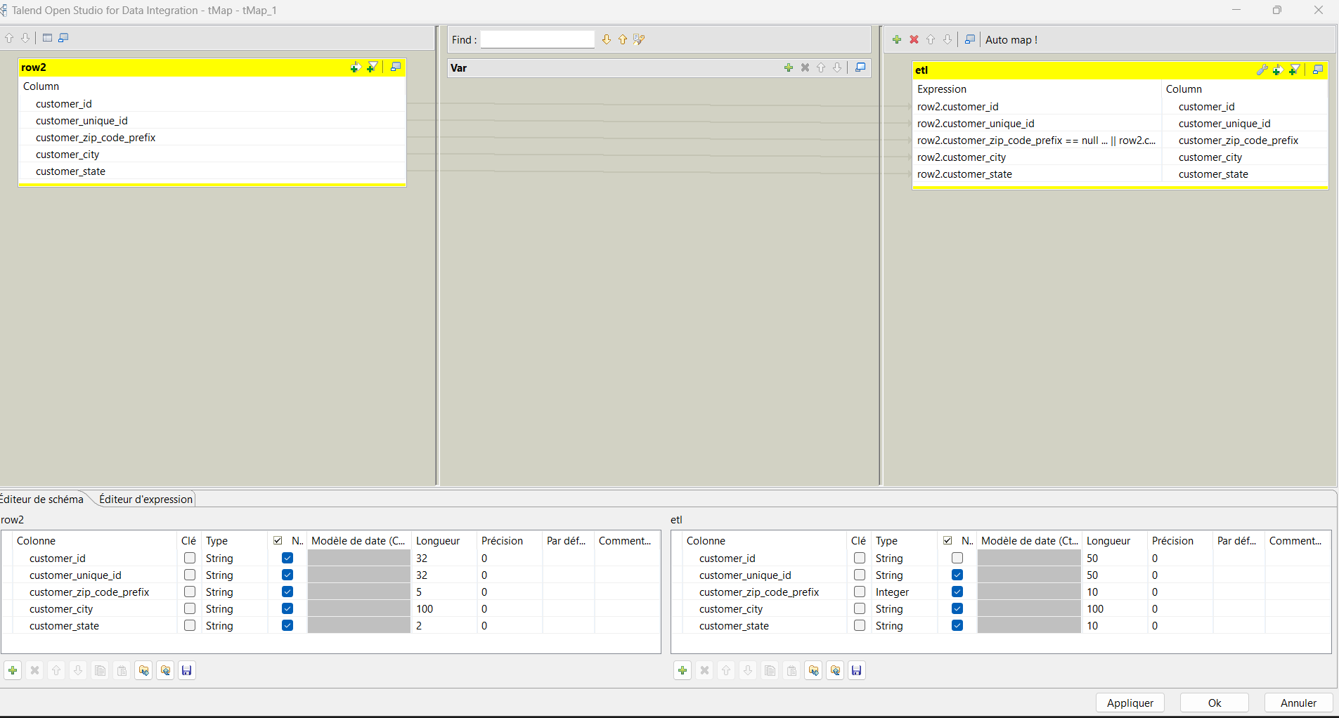

3.Date dimention etl job

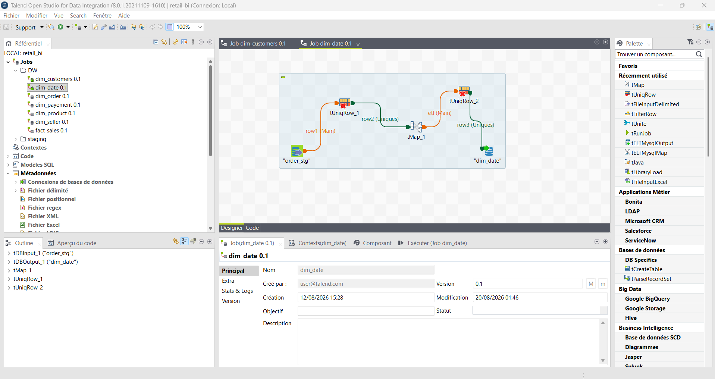

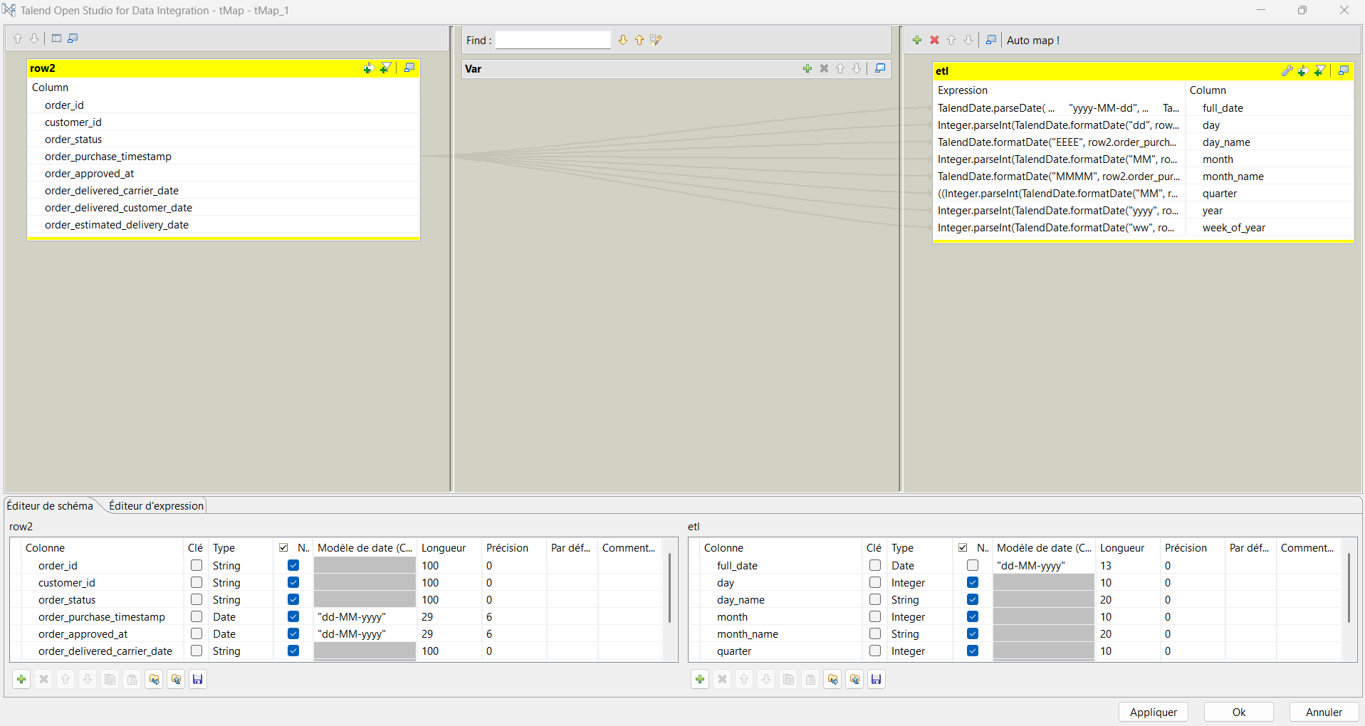

- Order dimention etl job

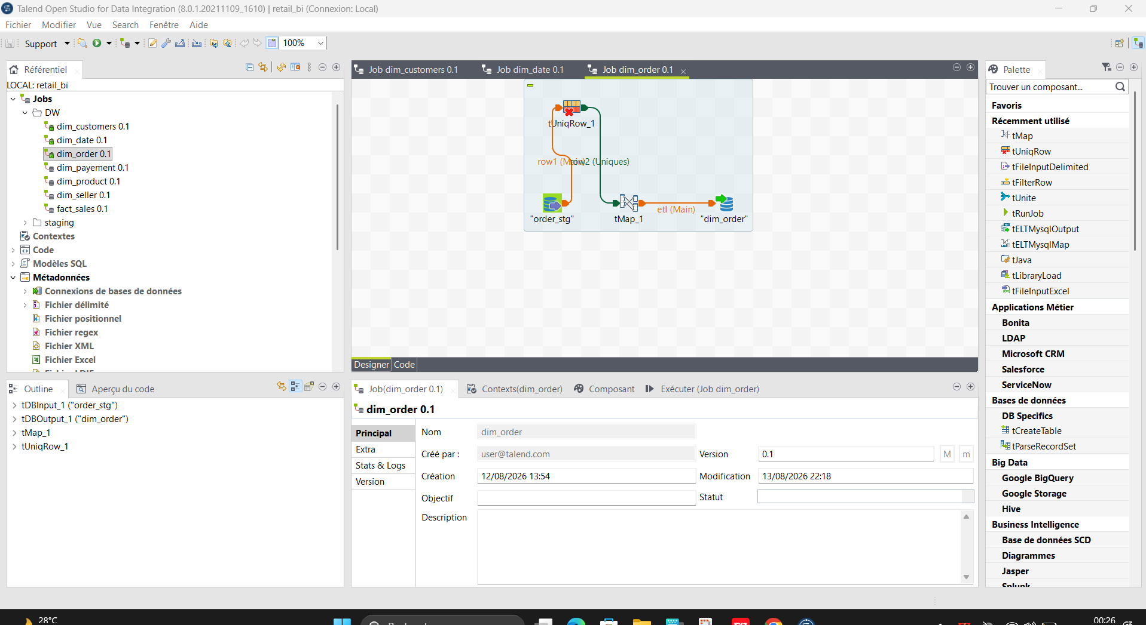

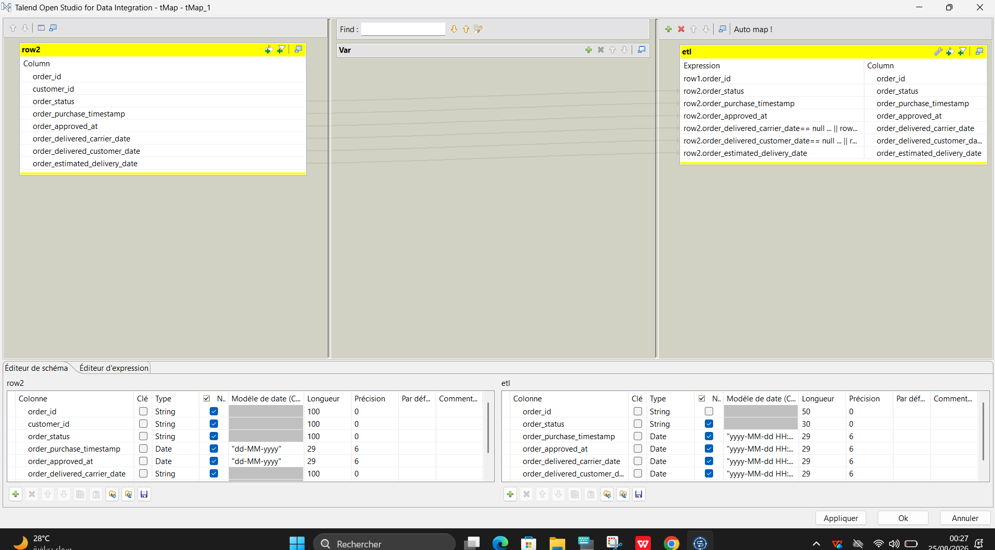

5.Payement dimention etl job

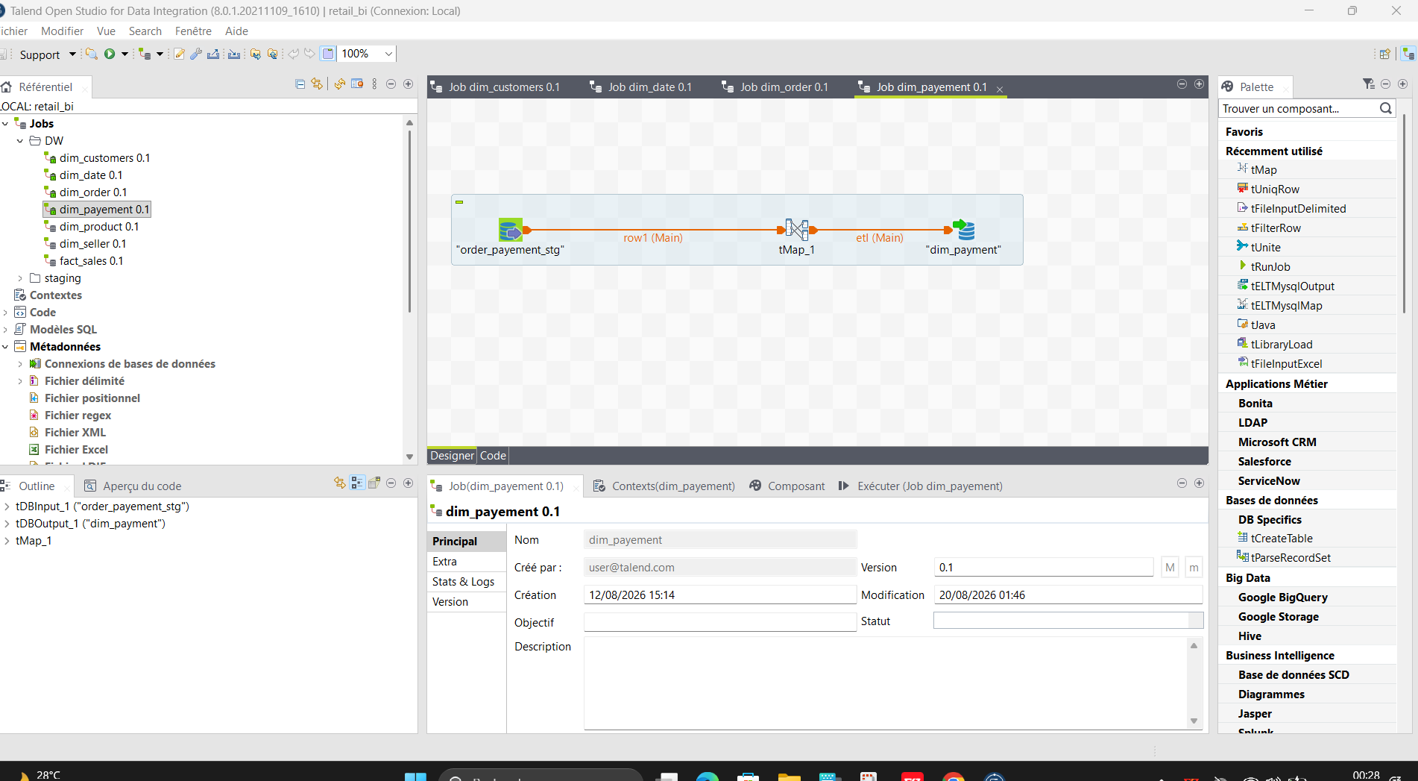

.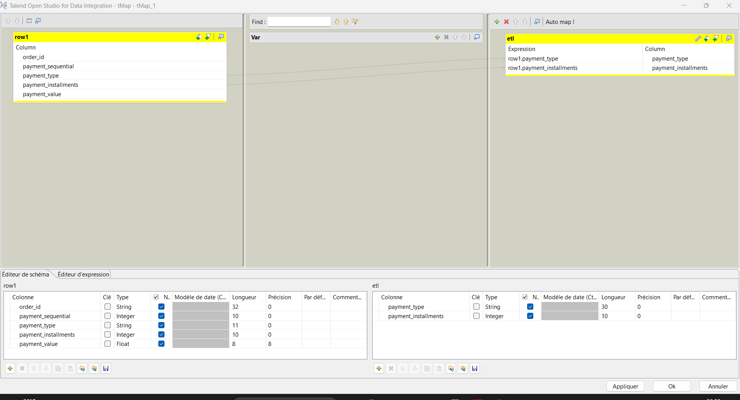

5.Product dimention etl job

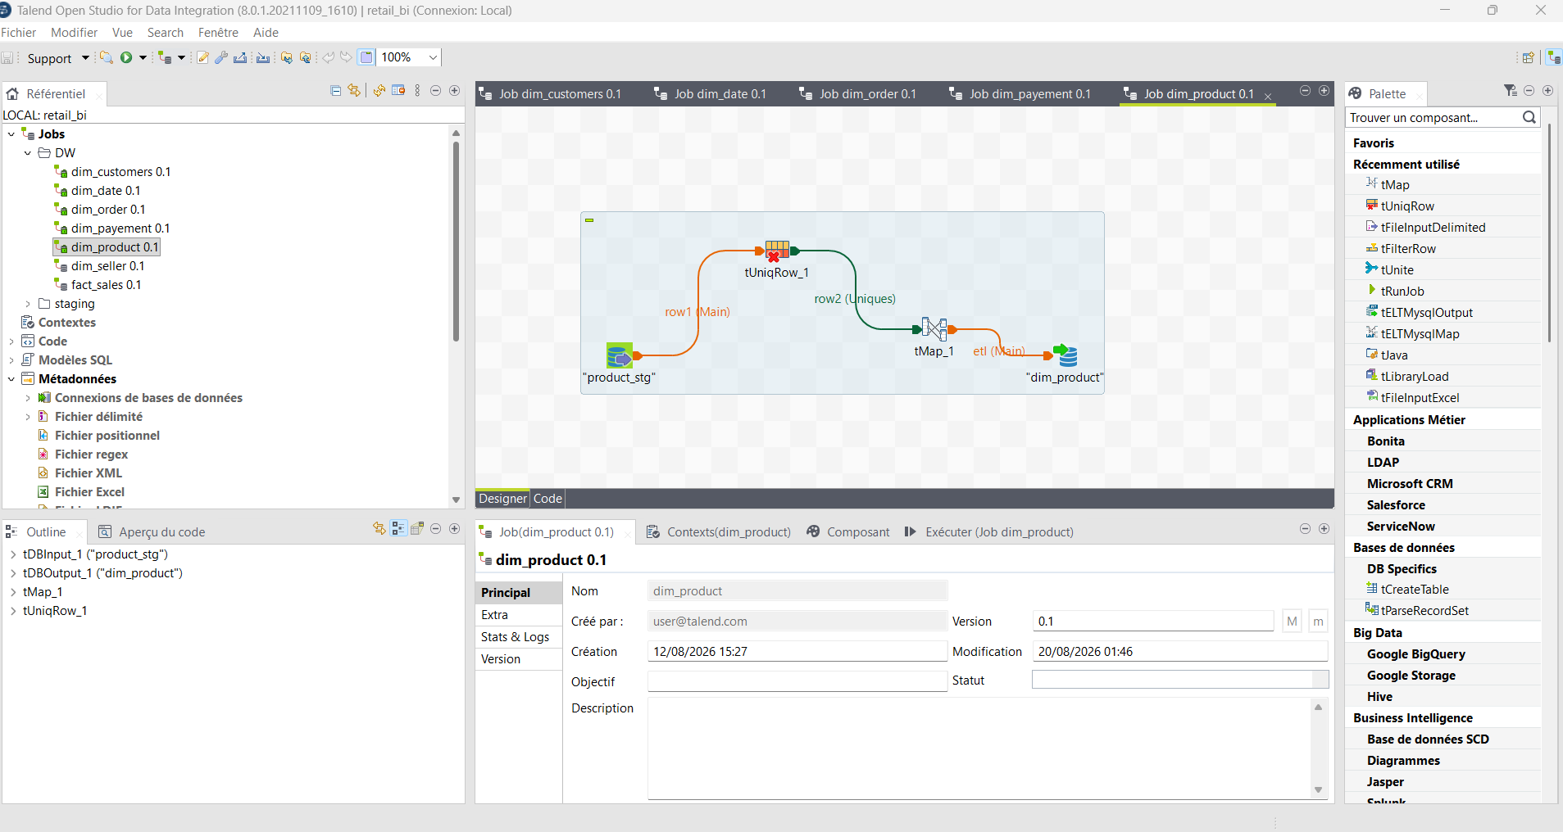

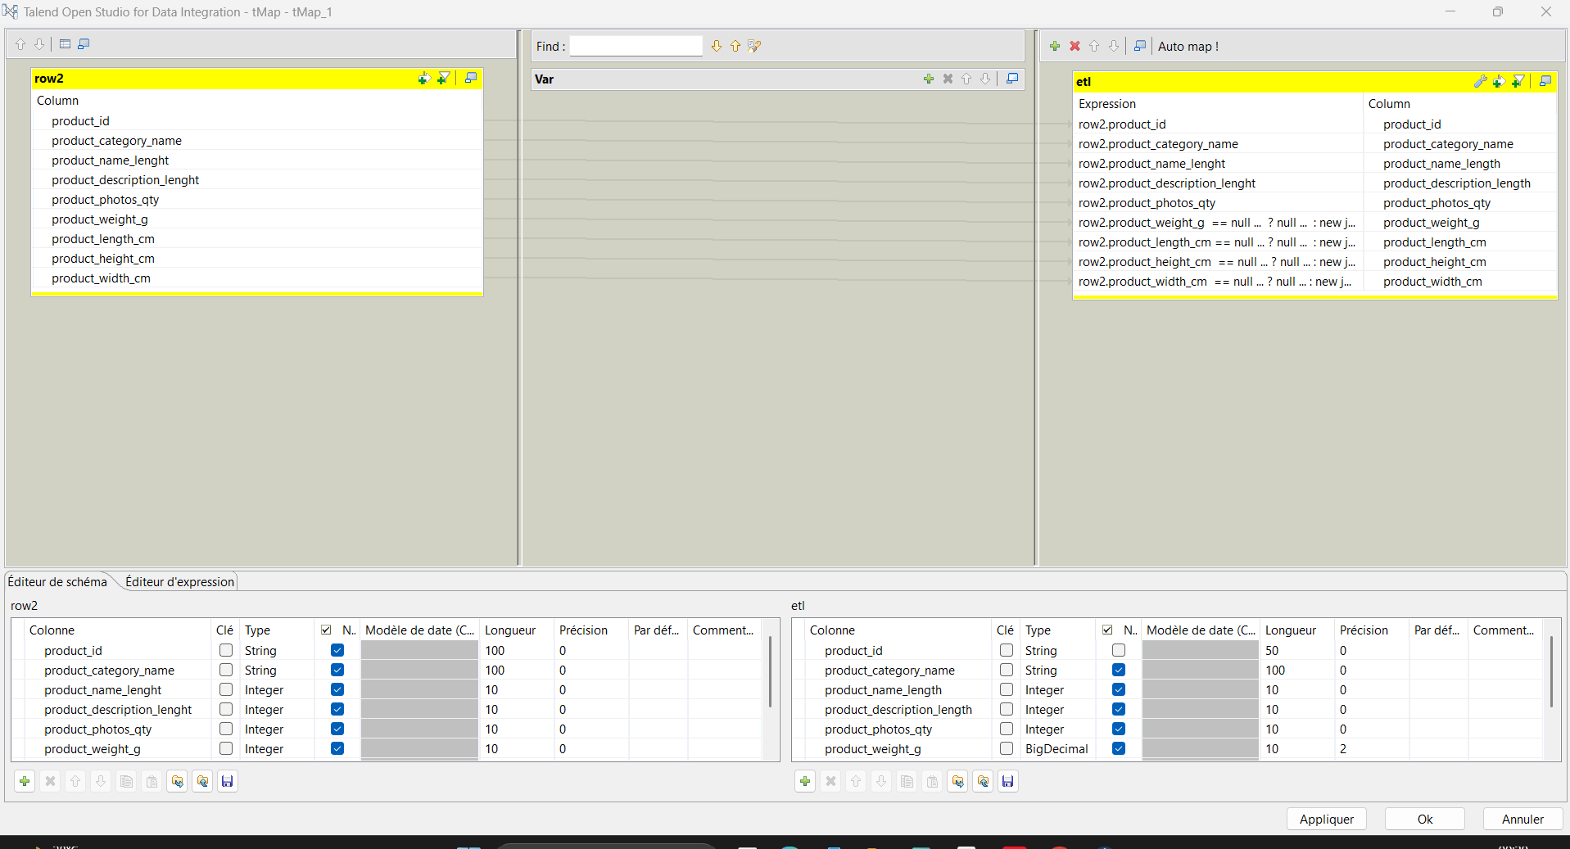

6.Seller dimention etl job

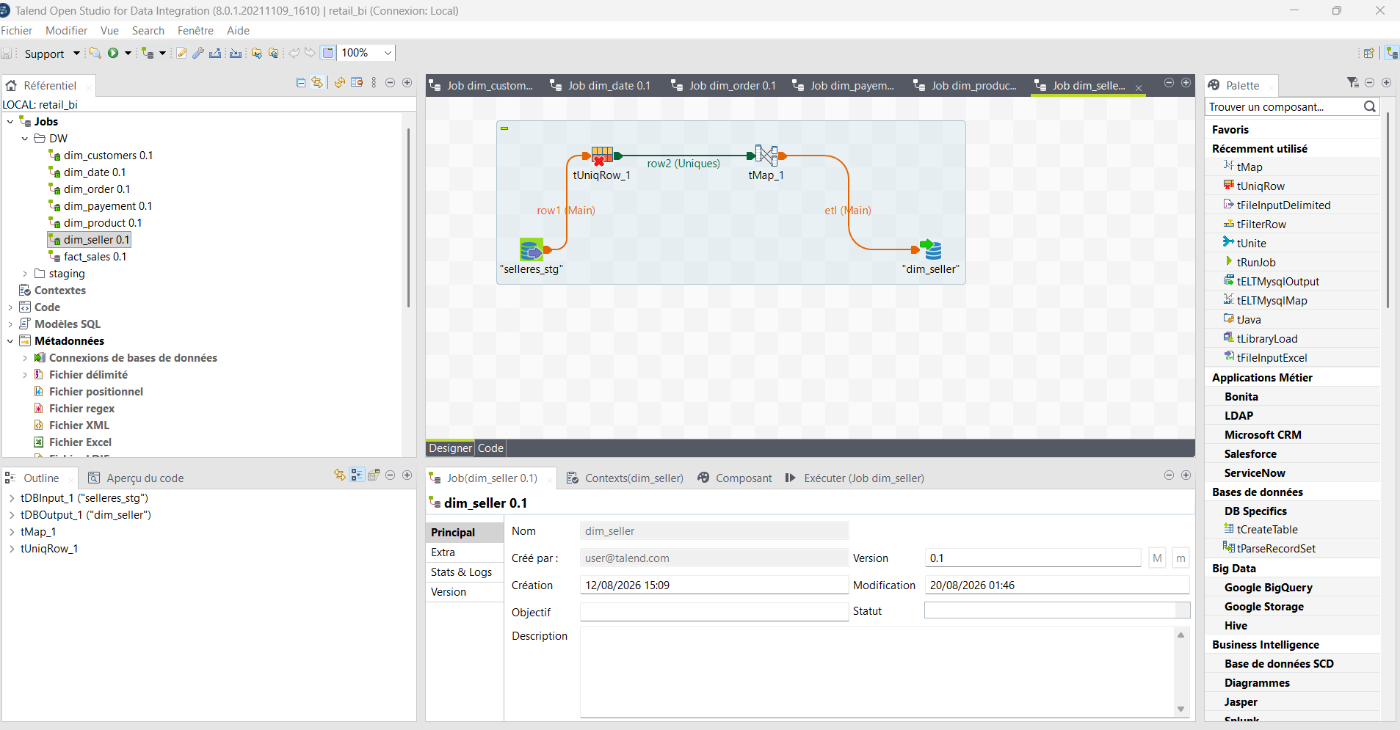

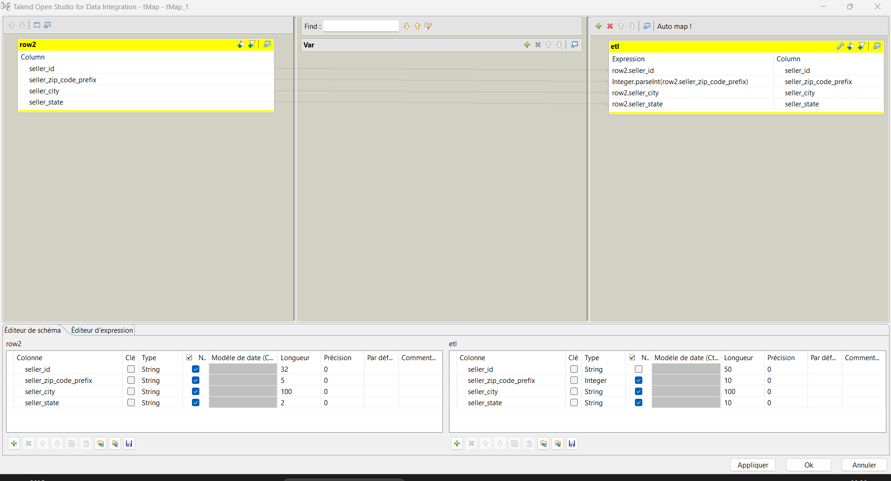

- Fact Sales etl job

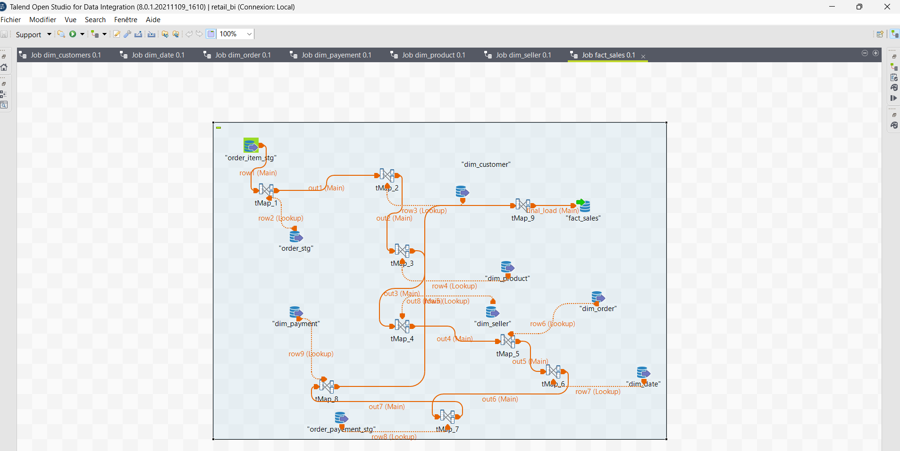

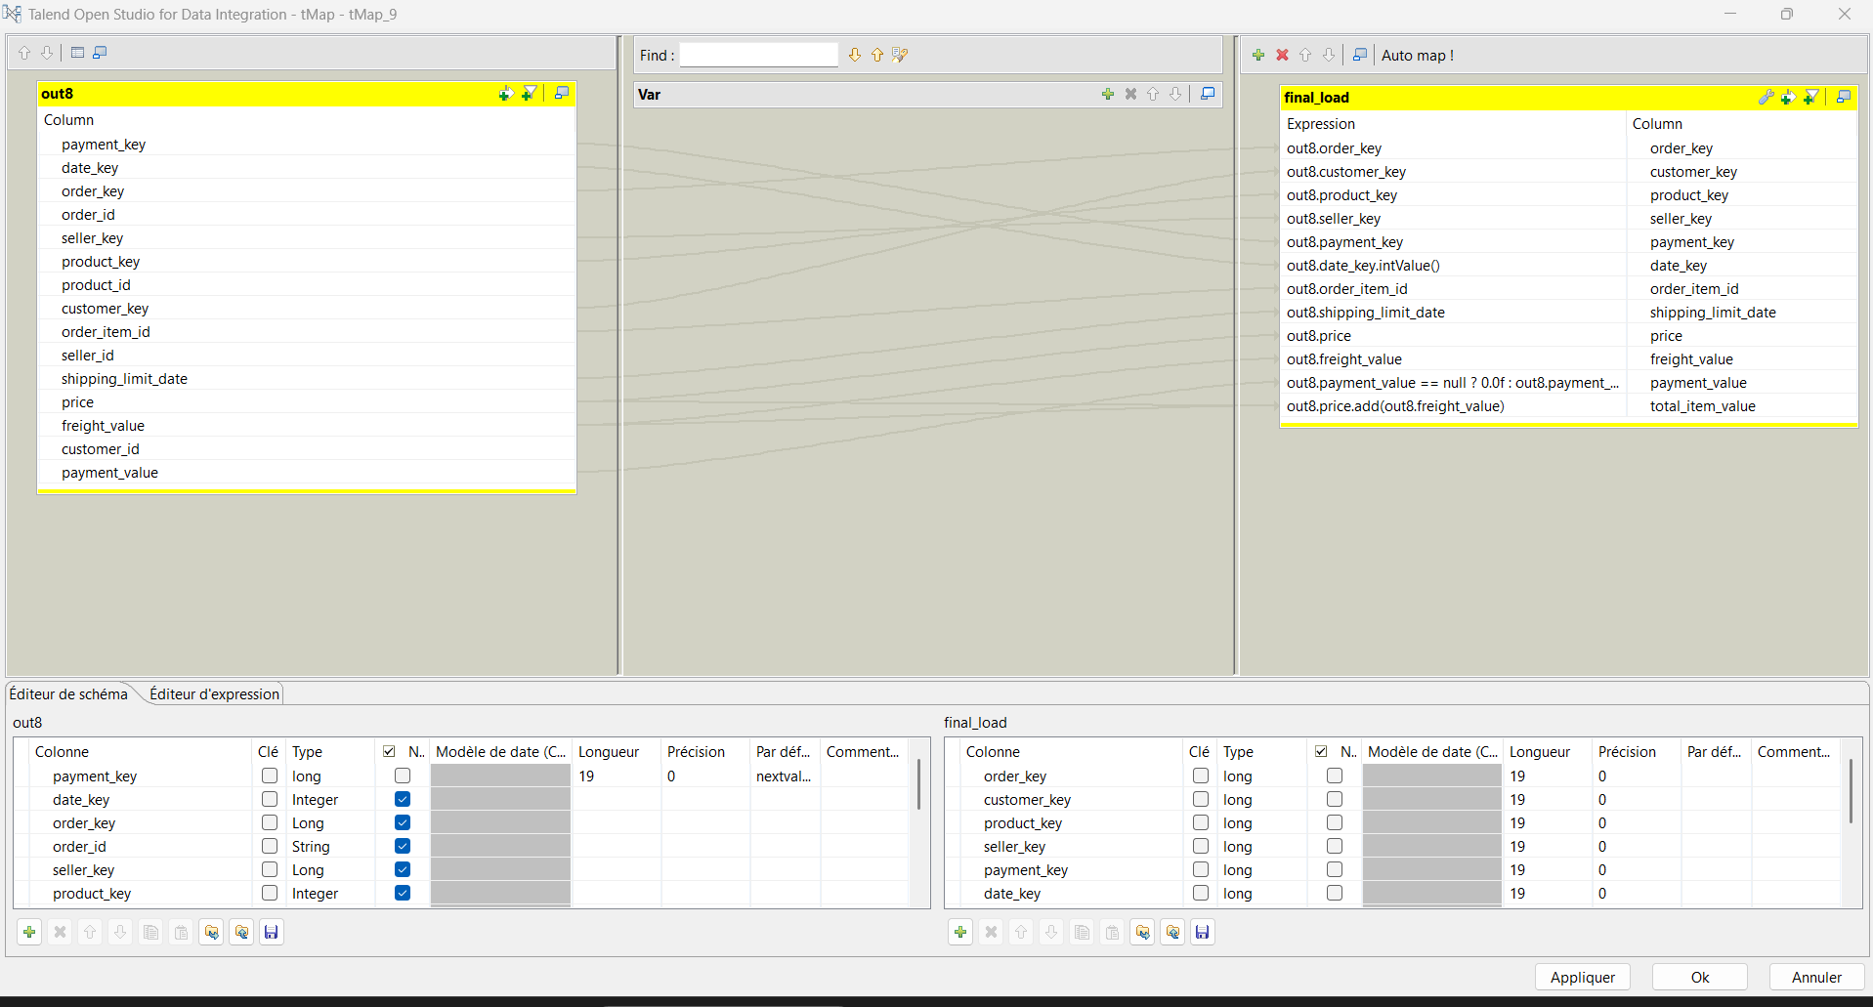
Conclusion
The ETL process implemented with Talend successfully transformed the raw Olist datasets into structured and reliable data suitable for Business Intelligence analysis. The developed jobs handled the extraction, transformation, validation, and loading of data into the PostgreSQL environment.
The ETL workflow covered the construction and population of the different dimension tables as well as the fact_sales table, ensuring consistency between the staging area and the Data Warehouse. Data type conversions, data cleaning, duplicate handling, and key management were also addressed throughout the process.

